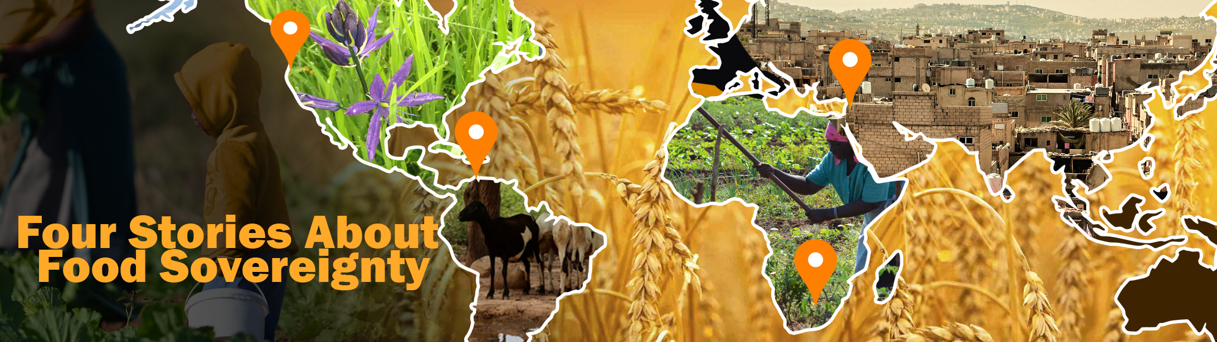Student Activity
Questions Researchers are Asking
Settings Pathway
fourstoriesaboutfood.org
NOTE TO TEACHERS:
This activity looks at questions researchers are asking food producers and small-scale farmers. You may decide to print or include Appendix A as part of this package, or not include it and have students access the questionnaire online via the link provided.

IMPORTANT!
Please note that questions such as these, if discussed in class, might bring up challenges that students themselves are facing with regards to access to food. Please read each question carefully, especially the ones in Appendix A, and think in advance about how to present this material while supporting students who may be experiencing food challenges at home.
BACKGROUND
The COVID-19 pandemic became a focus of researchers in 2020. The Four Stories researchers wondered: how did this crisis impact food security in the four settings?
Travel was restricted due to the pandemic so the Four Stories researchers were unable to visit the four settings to interview participants in person. Since the Four Stories project is a collaborative project with communities and researchers located around the world, local researchers were able to meet with the producers and small-scale farmers from their own communities. The small-scale farmers and producers were interviewed by local researchers and their answers have been translated into English with the help of some of the project researchers who speak the languages of the communities.
STUDENT ACTIVITIES
Below are the questions researchers developed for South Africa and Colombia. Read through them and then answer the questions for you and your own household. How might your own answers differ from those received by the researchers?

Have a look at the questions asked in The Household Food Security Survey Model (HFSSM) for Canadians found here (and also in Appendix A at the end of this document).

- What are your answers to these questions?
- Would your answers change if you thought about different time periods in the pandemic (March 2020 versus December 2020)?
Let’s consider how the construction of the HFSSM questions (i.e. how they are worded) differ in content from the ones asked of participants in South Africa and Colombia.
- What might this suggest?
- Are the questions in the HFSSM appropriate for everyone in Canada?
- What is not addressed in these questions?
Finally, reflect on how the challenges of food security and food sovereignty differ—or not—between the various settings. Below are questions researchers are asking in Colombia and South Africa.
- How do these compare to questions (and potential answers) being asked in Canada?
- What might these questions suggest about food sovereignty in each of the three settings discussed here?
QUESTIONS RESEARCHERS ARE ASKING: COLOMBIA AND SOUTH AFRICA
1. What was the state of your household’s food before the national COVID-19 pandemic emergency was declared? (Did you have enough food? Was it healthy food including vegetables and fruit? Did you have to skip meals? How often?)
2. What is the state of your household’s access to food now? (Did you have to reduce food or skip meals during the lockdown? Daily or how often?)
3. What impacts does the lockdown and ongoing emergency have on your household? Especially access to money and to food …
4. Did the government offer any extra support or protections – and were you able to access these?
5. What effects could the pandemic have on your household, your village, and your more distant relatives?
Visit our website for further information and statistics on food hunger in the world and in the settings under study: https://www.fourstoriesaboutfood.org.

Appendix A: Canadian Community Health Survey Household Food Security Survey Module (HFSSM)

The following questions are about the food situation for your household in the past 12 months.
Q1.* Which of the following statements best describes the food eaten in your household in the past 12 months, that is since [current month] of last year?
- You and other household members always had enough of the kinds of foods you wanted to eat.
- You and other household members had enough to eat, but not always the kinds of food you wanted.
- Sometimes you and other household members did not have enough to eat.
- Often you and other household members didn't have enough to eat.
Don't know / refuse to answer (Go to end of module)
The HFSSM begins here:
Now I'm going to read you several statements that may be used to describe the food situation for a household. Please tell me if the statement was often true, sometimes true, or never true for you and other household members in the past 12 months.
Q2. The first statement is: you and other household members worried that food would run out before you got money to buy more. Was that often true, sometimes true, or never true in the past 12 months?
- Often true
- Sometimes true
- Never true
Don't know / refuse to answer
Q3. The food that you and other household members bought just didn't last, and there wasn't any money to get more. Was that often true, sometimes true, or never true in the past 12 months?
- Often true
- Sometimes true
- Never true
Don't know / refuse to answer
Q4. You and other household members couldn't afford to eat balanced meals. In the past 12 months was that often true, sometimes true, or never true?
- Often true
- Sometimes true
- Never true
Don't know / refuse to answer
IF CHILDREN UNDER 18 IN HOUSEHOLD, ASK Q5 AND Q6; OTHERWISE, SKIP TO FIRST LEVEL SCREEN (below)
Now I'm going to read a few statements that may describe the food situation for households with children.
Q5. You or other adults in your household relied on only a few kinds of low-cost food to feed the child(ren) because you were running out of money to buy food. Was that often true, sometimes true, or never true in the past 12 months?
- Often true
- Sometimes true
- Never true
Don't know / refuse to answer
Q6. You or other adults in your household couldn't feed the child(ren) a balanced meal, because you couldn't afford it. Was that often true, sometimes true, or never true in the past 12 months?
- Often true
- Sometimes true
- Never true
Don't know / refuse to answer
FIRST LEVEL SCREEN (screener for Stage 2): If AFFIRMATIVE RESPONSE to ANY ONE of Q2-Q6 (i.e., "often true" or "sometimes true") OR response [3] or [4] to Q1, then continue to STAGE 2; otherwise, skip to end.
STAGE 2: Questions 7-11 - ask households passing the First Level Screen
IF CHILDREN UNDER 18 IN HOUSEHOLD, ASK Q7; OTHERWISE SKIP TO Q8
Q7. The child(ren) were not eating enough because you and other adult members of the household just couldn't afford enough food. Was that often, sometimes or never true in the past 12 months?
- Often true
- Sometimes true
- Never true
Don't know / refuse to answer
The following few questions are about the food situation in the past 12 months for you or any other adults in your household.
Q8. In the past 12 months, since last [current month] did you or other adults in your household ever cut the size of your meals or skip meals because there wasn't enough money for food?
- Yes
- No (Go to Q9)
Don't know / refuse to answer
Q8b. How often did this happen?
- Almost every month
- Some months but not every month
- Only 1 or 2 months
Don't know / refuse to answer
Q9. In the past 12 months, did you (personally) ever eat less than you felt you should because there wasn't enough money to buy food?
- Yes
- No
Don't know / refuse to answer
Q10. In the past 12 months, were you (personally) ever hungry but didn't eat because you couldn't afford enough food?
- Yes
- No
Don't know / refuse to answer
Q11. In the past 12 months, did you (personally) lose weight because you didn't have enough money for food?
- Yes
- No
Don't know / refuse to answer
SECOND LEVEL SCREEN (screener for Stage 3): If AFFIRMATIVE RESPONSE to ANY ONE of Q7-Q11, then continue to STAGE 3; otherwise, skip to end.
STAGE 3: Questions 12-16 - ask households passing the Second Level Screen
Q12. In the past 12 months, did you or other adults in your household ever not eat for a whole day because there wasn't enough money for food?
- Yes
- No (IF CHILDREN UNDER 18 IN HOUSEHOLD, ASK Q13; OTHERWISE SKIP TO END)
Don't know / refuse to answer
Q12b. How often did this happen?
- Almost every month
- Some months but not every month
- Only 1 or 2 months
Don't know / refuse to answer
IF CHILDREN UNDER 18 IN HOUSEHOLD, ASK Q13-16; OTHERWISE SKIP TO END
Now, a few questions on the food experiences for children in your household.
Q13. In the past 12 months, did you or other adults in your household ever cut the size of any of the children's meals because there wasn't enough money for food?
- Yes
- No
Don't know / refuse to answer
Q14. In the past 12 months, did any of the children ever skip meals because there wasn't enough money for food?
- Yes
- No
Don't know / refuse to answer
Q14b. How often did this happen?
- Almost every month
- Some months but not every month
- Only 1 or 2 months
Don't know / refuse to answer
Q15. In the past 12 months, were any of the children ever hungry but you just couldn't afford more food?
- Yes
- No
Don't know / refuse to answer
Q16. In the past 12 months, did any of the children ever not eat for a whole day because there wasn't enough money for food?
- Yes
- No
Don't know / refuse to answer
End of module
*Question Q1 is not used directly in determining household food security status.

